Membership System Update

1. Button Shortcut key - POS Counter ✅
2. Following panda receipt rounded number into point (done by panda side)

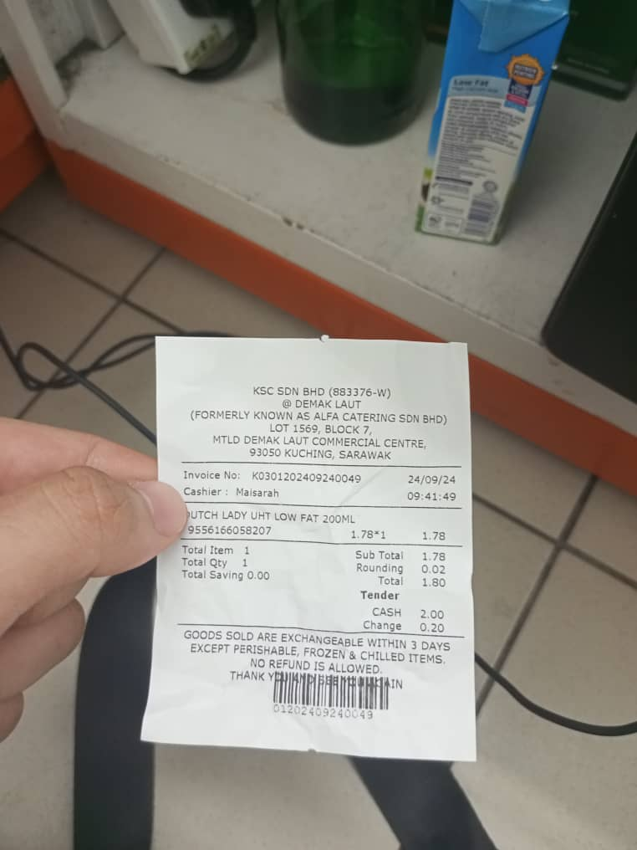

1. Customer database - 4 right admin ( each can open ) ✅
2. Screenshot database login ✅
3. Backup customer database ( weekly -> system and daily -> data ) - 4 week end in HQ Computer ✅
4. Locked backup data of customer in php. ✅

Admin Login

1. Register your admin at [www.kscfi.xyz/admin](http://www.kscfi.xyz/admin).
2. Then register your Name and Password.

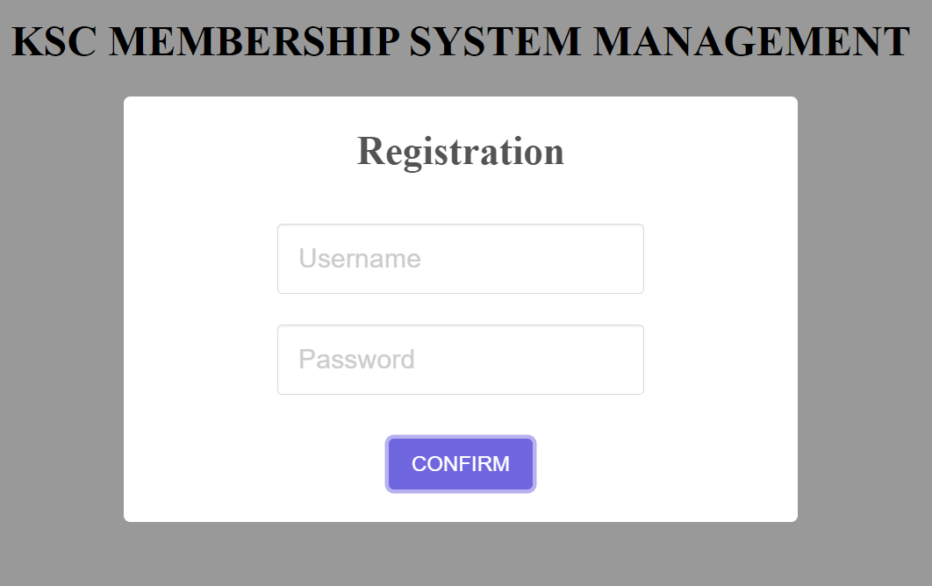

1. After that, admin are registered. Note that, only 4 admin are able to register into the system and the registration will be closed.
2. After register, admin can see the KSC membership management menu.

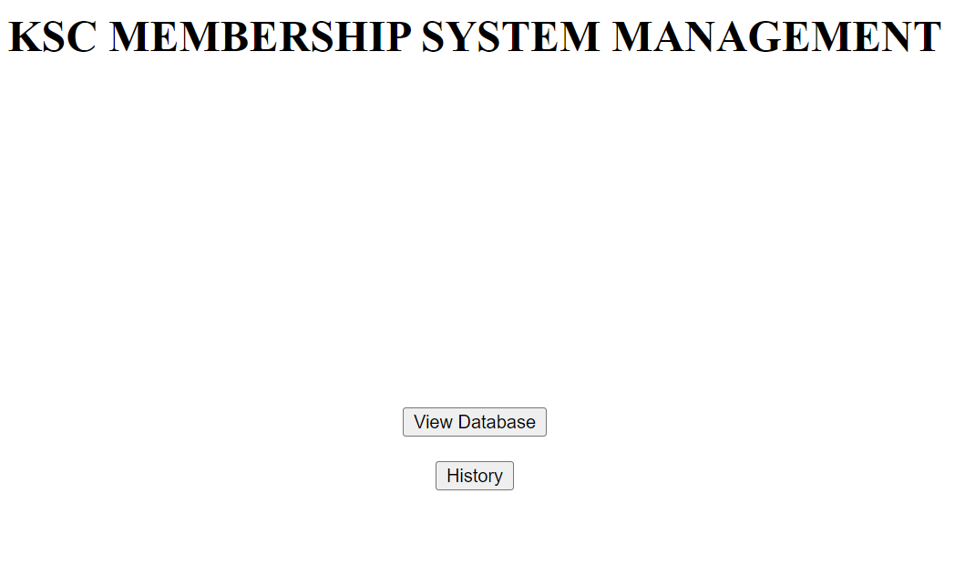

1. When the admin want to check database. Admin can click “View Database”. Then it will show login to secure the admin identity.

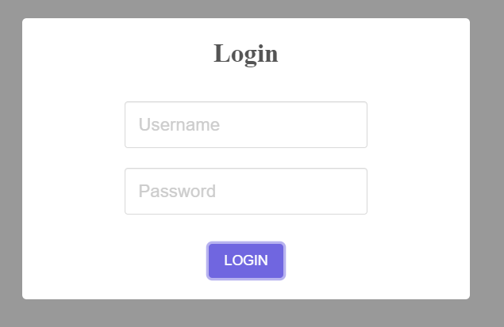

1. After successful login, admin can view the data set of the customer inside the database.

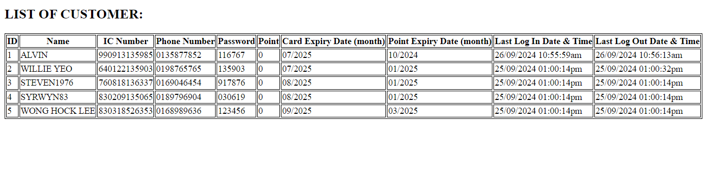

1. To view the history login of admin. Admin can click on the “History” button.



1. After that, admin need to login again to ensure it secure every time the admin visit.



1. After successful login it will show the admin record of login by the admin.  
   